**B. Tech CSE AY 2022-23**

**Project Management**

**Assignment No 2 (LA-2)**

**Prn : 2019btecs00091**

**Batch : B8**

1. Create a project (give name of your project) in Jira, use template as Scrum and add your team members into this project.

Creating a project with name “Skin Disease Detection”

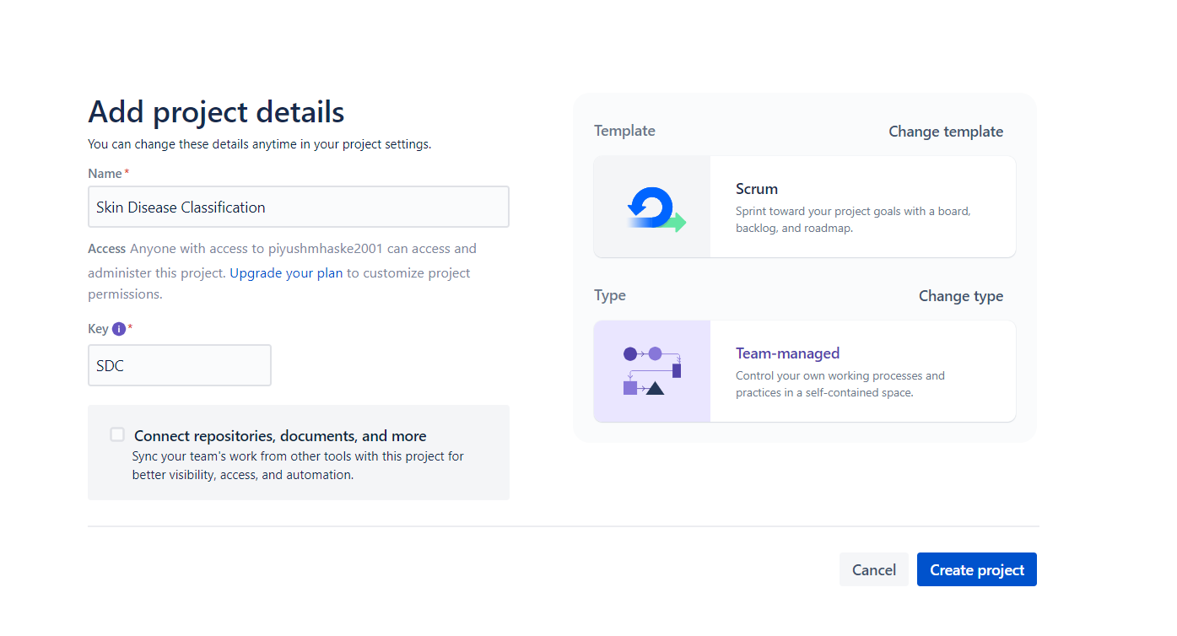

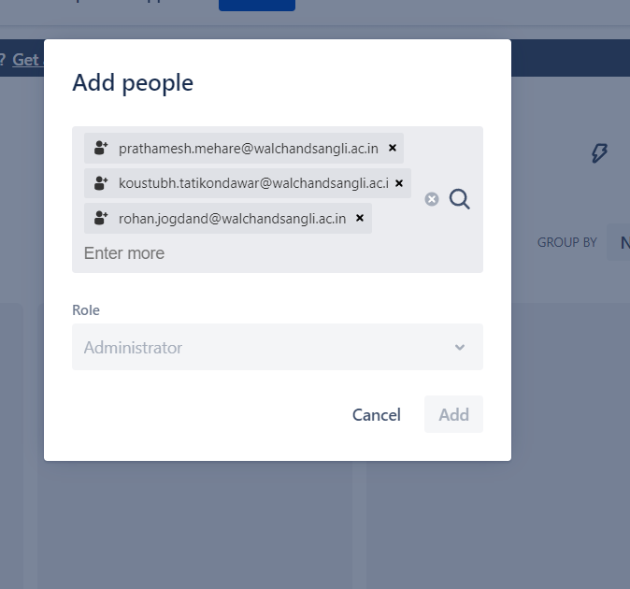

1. Create an Epic into above project (main requirement of your project, e.g Creating a web application for student result generation).

Epics Created for Skin Disease Classification

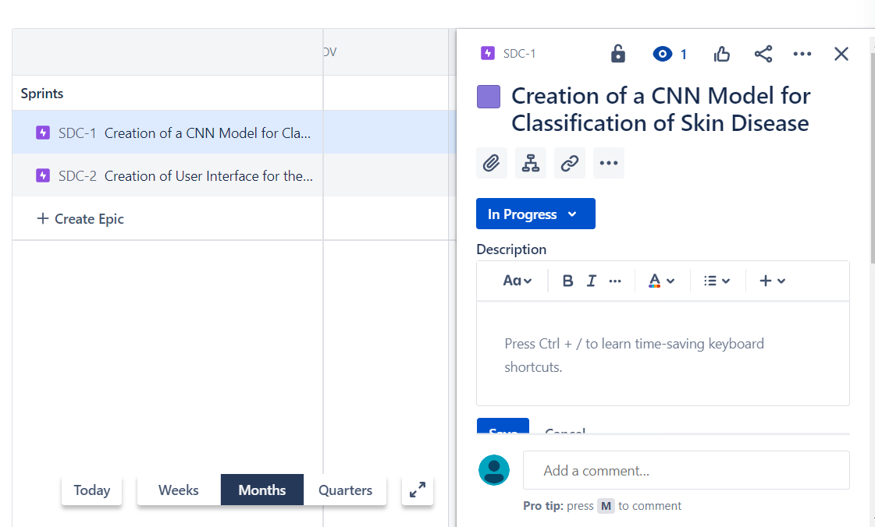

1. Create at least 5 user stories with respect to above epic for your project.

Created User Stories for the Epic : Creation of CNN Model for Classification of images.  
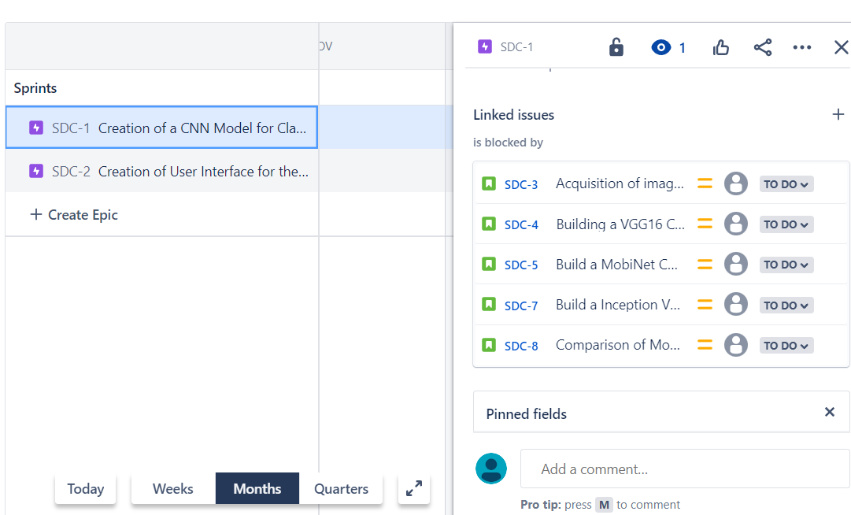

1. Create at least 2 subtasks for every user story. Assign user stories to your team members.

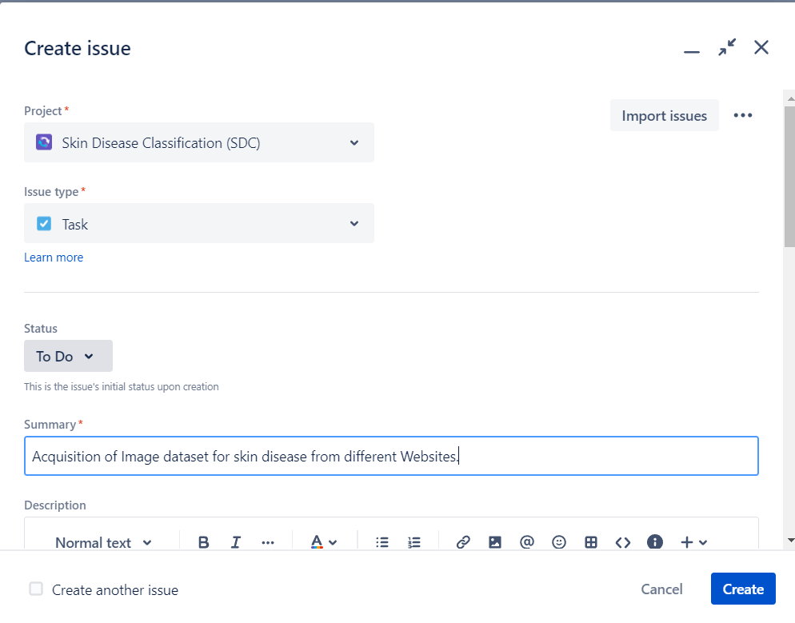

And Assigned it to one of the team members.

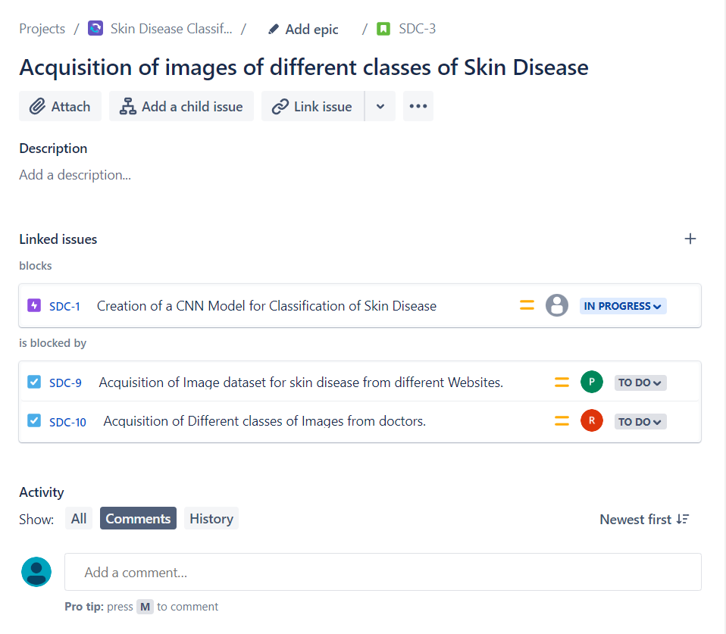

1. Create sprints for every use stories and prioritize them according to your tasks. Assign time period for every user story.

Created the sprint, and assigned them a time period.

1. Update the status of some user stories as To Do, In Progress or Completed according to sprints (add appropriate comments).

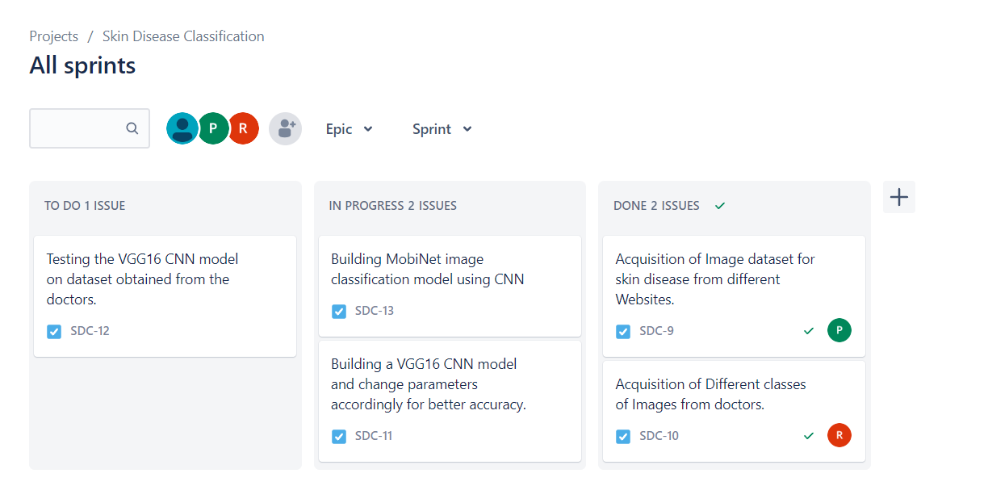

1. Create a bug/issue for respective user story and epic and assign to respective member.

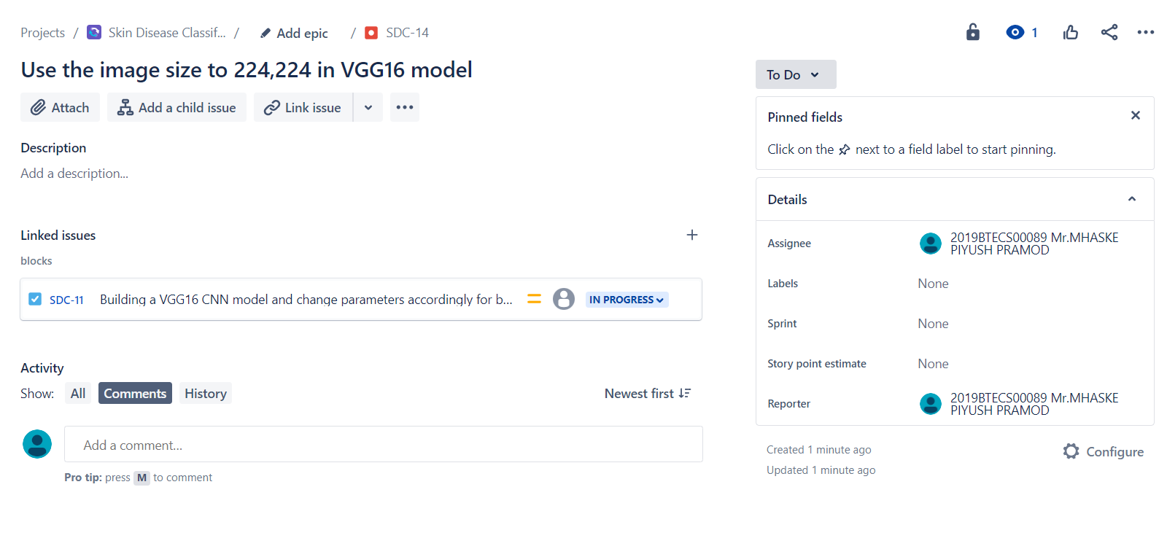

1. Display reports (Burnup chart, Burndown chart) w.r.t your created project.

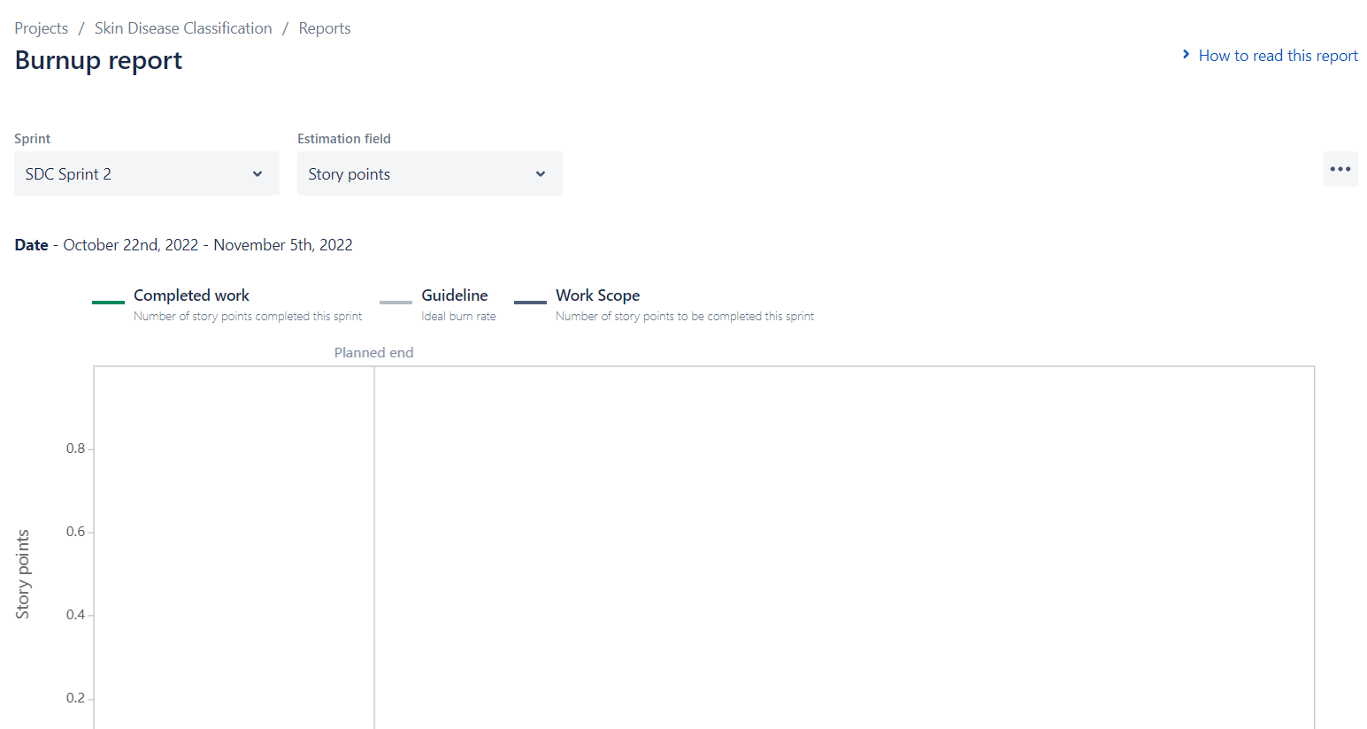

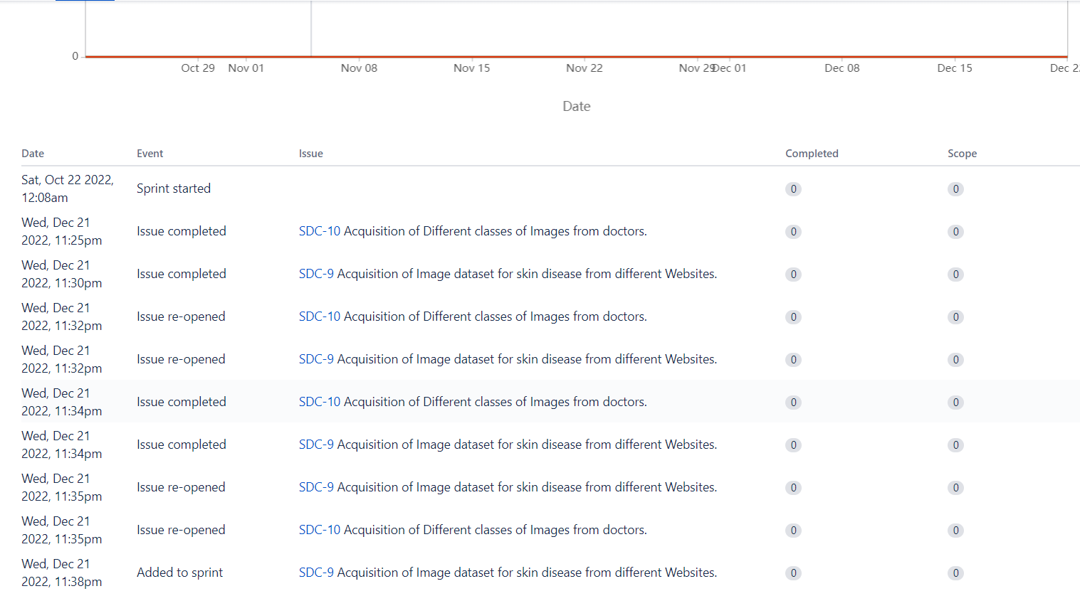

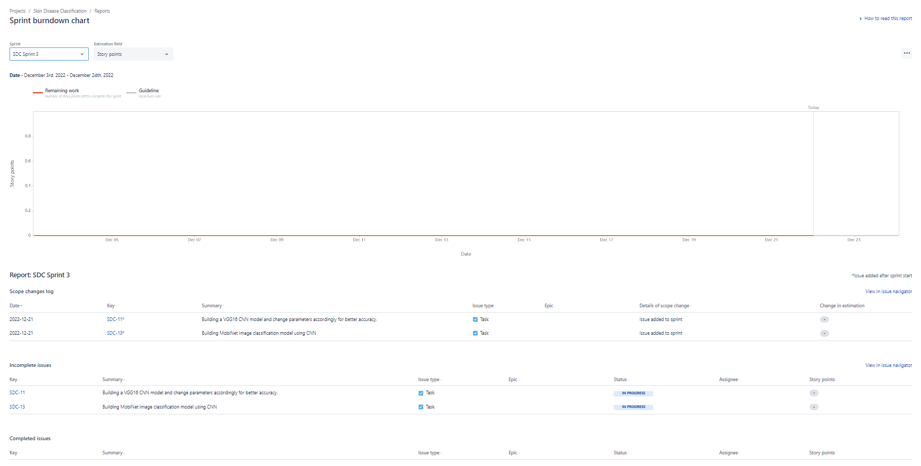

**Note**- 1. For every answer provide screenshots.

2. Please use reference material <https://www.atlassian.com/agile> from this site and reference video <https://www.youtube.com/watch?v=HzJzB0nQYlk>